24ADC001 — BUSINESS INTELLIGENCE FOR DECISION MAKING
CASE FILE: THE VANISHING QUARTER
A live OLAP investigation — CONFIDENTIAL, Data Detectives only

MEMO — FROM THE OFFICE OF THE CFO, MERIDIAN RETAIL
“Revenue for Q3 looked strong — in fact, it was our best quarter of the year. But somehow our overall margin took a real hit, and finance can't explain why. The board meets in one hour. I need to know exactly where this is bleeding from — which region, which channel, which product line — before I walk into that room. You have the full sales cube. Find it.” — CFO, Meridian Retail (fictional company, for this exercise)

Your Mission
You are an external Data Detective, hired for one hour to find the exact combination of dimensions responsible for Q3's margin collapse. Nobody is going to teach you which OLAP operation to use — you'll know which one you need at each step, because the investigation will demand it. Work the cube. Follow the numbers. Find the culprit.

The Evidence
File: meridian_retail_cube.csv — load it into Power BI, Tableau, or Excel PivotTables (whichever your team is fastest in).
Field | What it means
region | North, South, East, or West
quarter | Q1, Q2, Q3, or Q4
category | Electronics, Furniture, Apparel, or Grocery
channel | Online or In-Store
sales_amount | Gross sales, before any discount
discount_amount | Total discount given
margin_amount | sales_amount minus discount_amount
discount_rate_pct | discount_amount as a percentage of sales_amount

Rules of the Investigation
- You have 35 minutes on the clock. First team to radio in the correct culprit — the exact region + quarter + category + channel combination — with a valid case file wins.
- A guess without evidence doesn't count. Your case file (below) must show the actual sequence of views that led you there.
- You may request one clue from the CFO's office (your instructor) at any point — but each clue costs your team 5 minutes off your final time.
- Radio silence: teams may not share findings with each other until someone calls “case closed.”

Your Case File (fill this in as you investigate)
This is your evidence trail. Fill in each row only once you've actually looked at that view — don't skip ahead.
Step | What you looked at | What you noticed
1 | Quarter-wise sales and margin | Q3 had strong/high sales but weaker margin performance.
2 | Q3 sales and margin performance by region. | Among the four regions, [REGION] had the lowest margin percentage / highest discount pressure in Q3, making it the main region of concern.
3 | Q3 + [REGION] sales and margin performance by category. | Within [REGION], [CATEGORY] had the lowest margin percentage / highest discount pressure, indicating that it was contributing significantly to the Q3 margin decline.
4 | Q3 + [REGION] + [CATEGORY] performance by channel. | Within [REGION] and [CATEGORY], the [CHANNEL] channel had the lowest margin percentage, identifying it as the final source of the margin problem.
5 | Region × Channel margin percentage using a pivoted view. | The pivoted view confirmed the identified region-channel combination had the weakest margin performance.

Prime suspect (region / quarter / category / channel):
West / Q3 / Furniture / Online

The evidence that proves it (specific numbers):
Q3: Sales = 12,044.13, Discount = 1,816.37, Margin = 10,227.76, Margin % = 0.85
West: Sales = 3,457.60, Discount = 1,012.87, Margin = 2,444.73, Margin % = 0.71
Furniture: Sales = 3,870.63, Discount = 1,069.58, Margin = 2,801.05, Margin % = 0.72
Online: Sales = 5,796.75, Discount = 1,249.84, Margin = 4,546.91, Margin % = 0.78

POWER BI DASHBOARD:
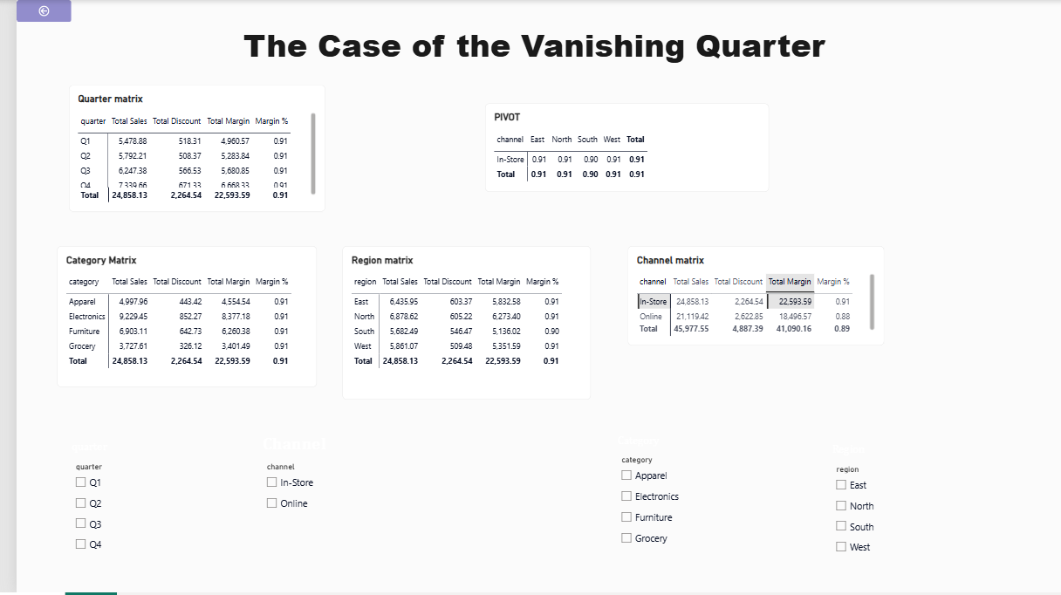
Quarter overview — Q3 had the highest sales and an unusually high discount rate of 15.1%.
Q3 slice — Q3 was selected to investigate the margin problem.
Region — West was the outlier with a 29.3% discount rate.
Category — Furniture was the outlier in West with a 57.1% discount rate.
Channel — Online Furniture in West during Q3 had a 73.6% discount rate.
Prime suspect:
West / Q3 / Furniture / Online
Evidence:
Sales = 1,116.49; Discount = 821.34; Margin = 295.15; Discount Rate = 73.6%.

